# Design Document - Invoice Validation System

## Overview

This document describes a proof-of-concept invoice validation system that

uses real PDF invoices from the internet, runs OCR to extract fields, compares

them against ground truth and PO/database records, highlights discrepancies,

and outputs validation status with confidence.

## Approach

1. Data ingestion + OCR

- `data/sources.csv` drives downloads into `data/raw_pdfs/`.

- Render PDFs to PNG at 300 DPI with optional scan simulation.

- Run Tesseract OCR (eng+vie) to get word boxes, line text, and confidence.

- Save raw OCR to `outputs/ocr_raw.json`.

2. Ground truth + database

- Parse the PDF text layer to build `data/ground_truth.json` (header fields

+ basic line items where possible).

- Clean noisy name/address candidates and skip obviously invalid labels.

- Build `data/database.json` (PO + vendor_master + customer_info), and inject

negative cases for ~30% invoices to show business-rule discrepancies.

3. Normalization

- Text: lowercase, strip punctuation, collapse whitespace.

- Company suffix normalization (inc, llc, ltd, co).

- Address abbreviation normalization (street -> st, drive -> dr).

- OCR confusable mapping (O/0, I/1/l, S/5, B/8).

4. Matching and validation

- ID fields (PO): exact match after OCR-confusion normalization.

- Names/addresses: fuzzy similarity (token set + edit ratio).

- Dates: tolerance window in days.

- Amounts: absolute and relative tolerance.

- Database references:

- PO vendor used as primary expected vendor name.

- vendor_master address used for vendor address validation when available.

- customer_info billing_address used for customer address validation.

- tax_rate from PO used to cross-check tax_amount.

- Line items: parse text to (description, qty, unit_price, total).

- Item not in PO list -> critical.

- Quantity above max -> critical.

- Line total mismatch -> warning.

5. Discrepancy scoring and status

- Discrepancy severity: critical / warning / informational.

- Overall confidence combines OCR confidence and rule penalties.

- Status logic:

- critical -> rejected.

- warnings or low confidence -> needs_review.

- otherwise approved.

6. Option A (ML)

- Logistic regression predicts probability a field is wrong.

- Features: OCR confidence, text length, digit ratio, fuzzy score,

amount/date diffs, field identity.

- Model output calibrates confidence per field and overall score.

7. Output generation

- `scripts/generate_sample_outputs.py` writes JSON results per invoice.

- `src/output/visualize.py` draws highlighted PNGs from discrepancy boxes.

## Sample Outputs (Images)

These are example highlighted outputs showing discrepancy boxes.

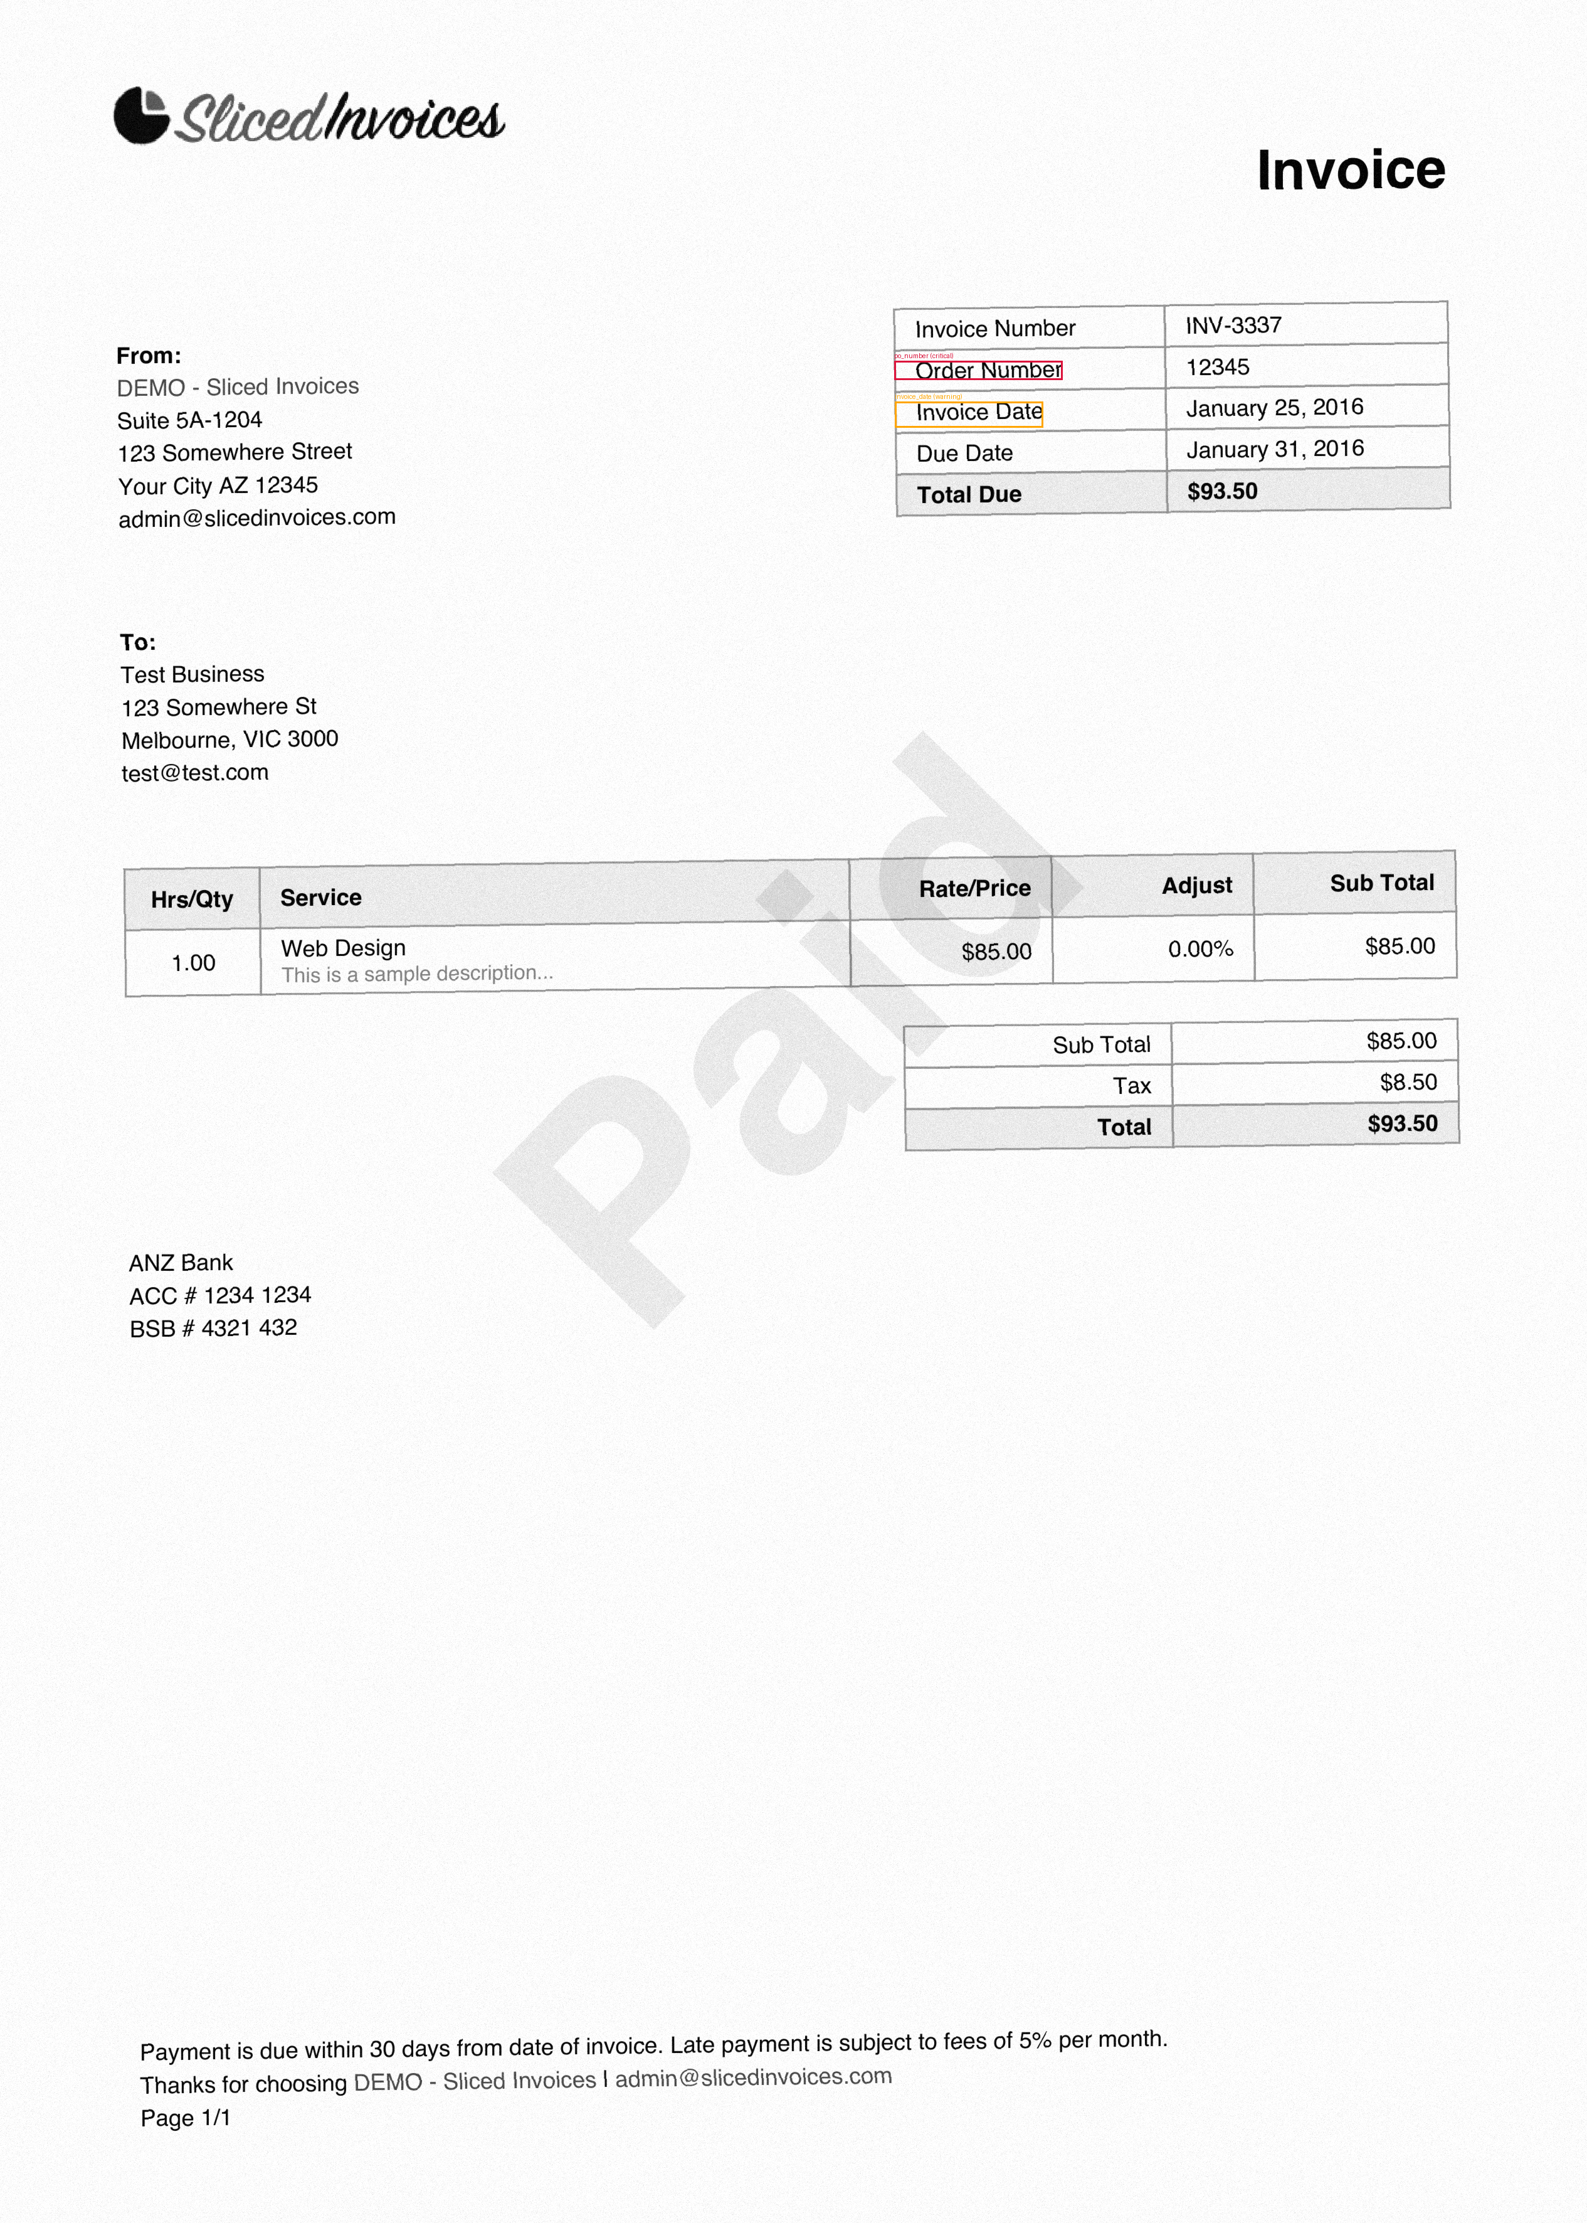

INV-G-001 header highlights

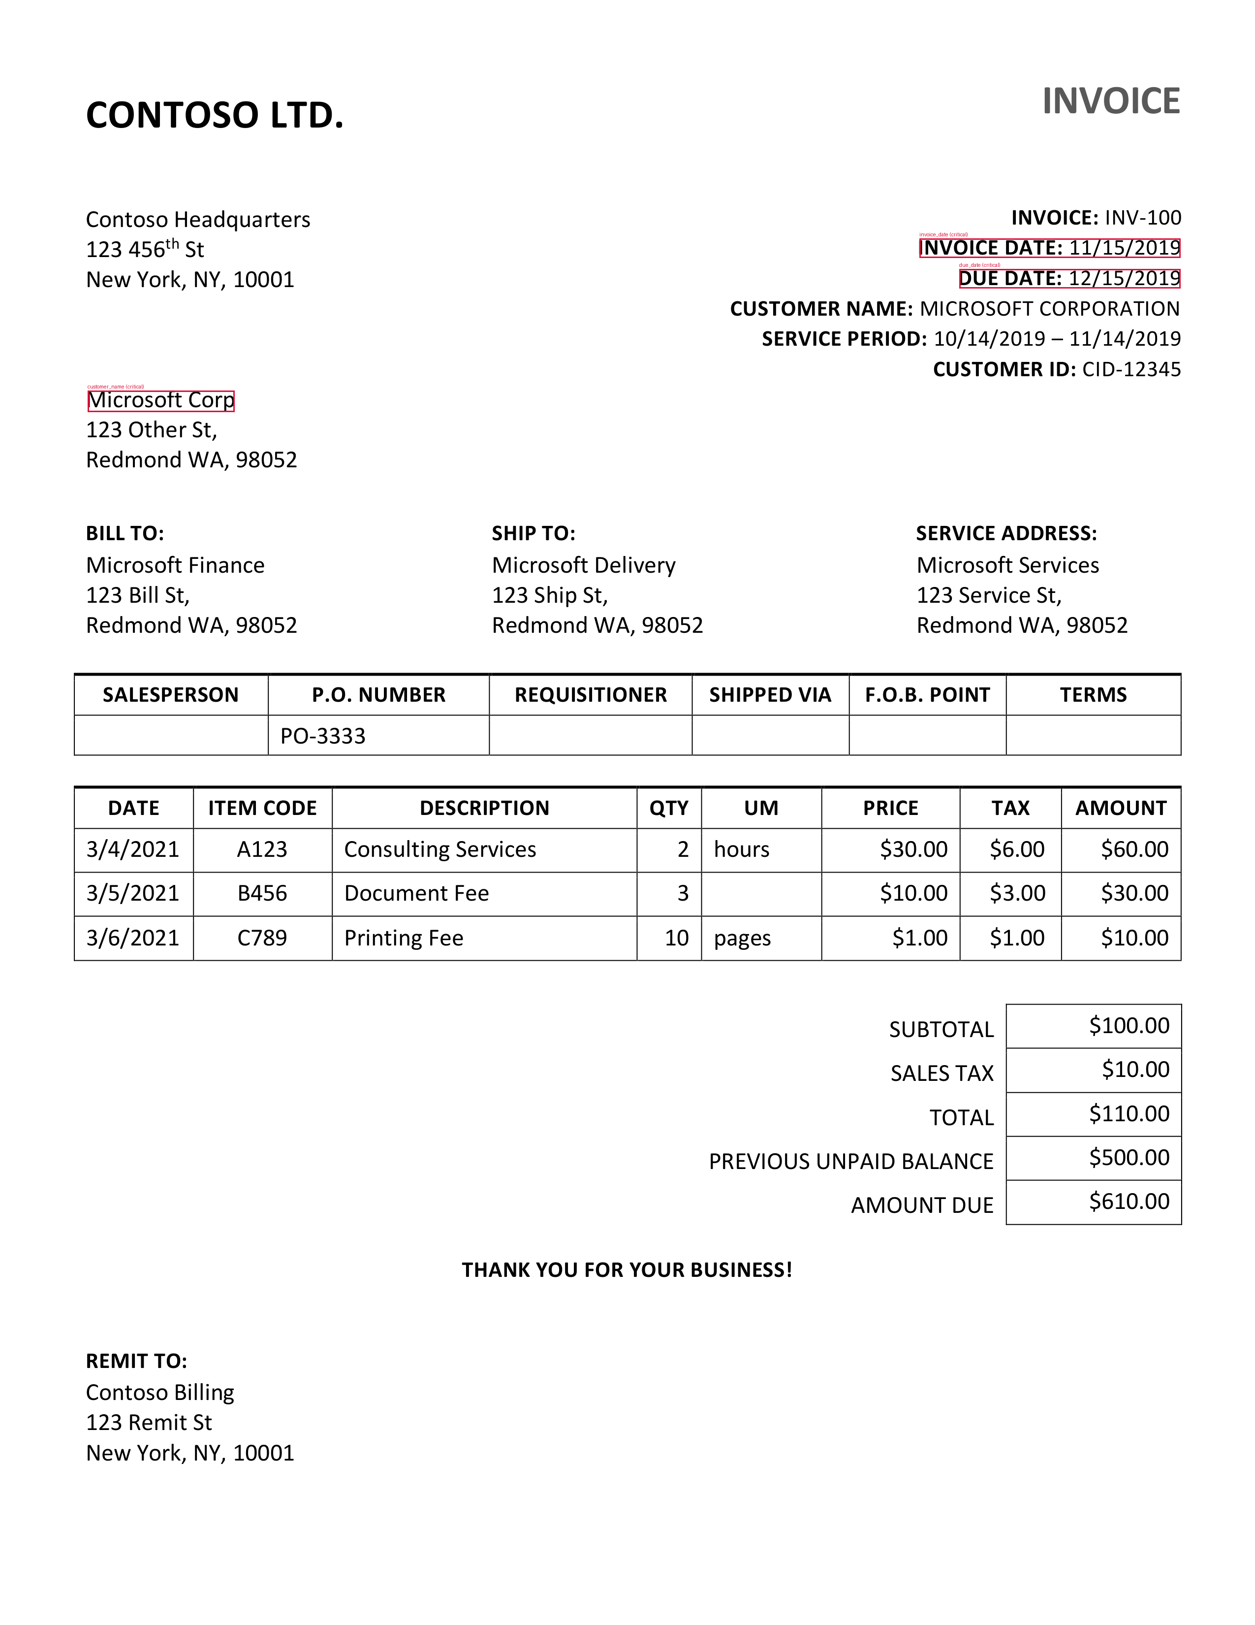

INV-G-003 header + line item highlights

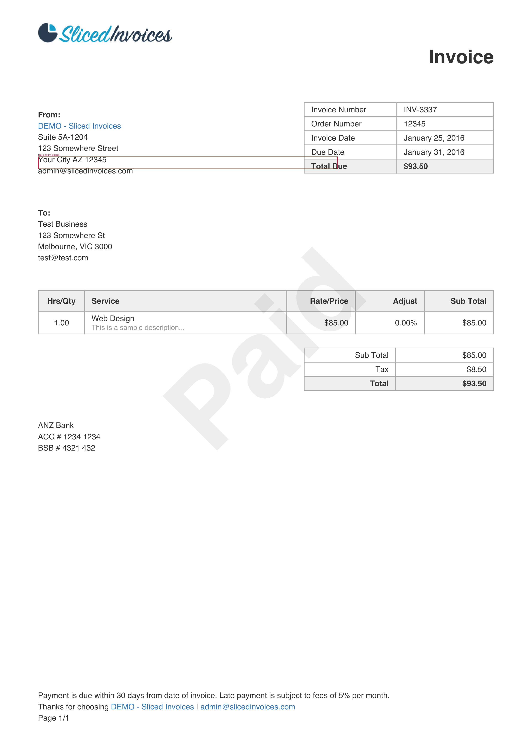

INV-G-010 header highlights

## Ground Truth vs PO Comparison (Example)

Ground truth comes from `data/ground_truth.json` and PO data comes from

`data/database.json`. The validator compares OCR results against ground truth

and then cross-checks against PO constraints (vendor, tax_rate, approved_amount).

Ground truth entry (invoice_id = INV-G-010):

{  
 "invoice_id": "INV-G-010",  
 "source_pdf": "data/raw_pdfs/INV-G-010.pdf",  
 "expected_data": {  
 "vendor_name": null,  
 "vendor_address": null,  
 "customer_name": "Test Business",  
 "customer_address": "123 Somewhere St, Melbourne, VIC 3000",  
 "po_number": "12345",  
 "invoice_date": "2016-01-25",  
 "due_date": "2016-01-31",  
 "subtotal": 85.0,  
 "tax_amount": 8.5,  
 "total_amount": 93.5,  
 "line_items": []  
 }  
}

PO record used for comparison (po_number = 12345):

{  
 "po_number": "12345",  
 "vendor": null,  
 "approved_amount": 93.5,  
 "valid_items": [],  
 "max_quantity": {},  
 "tax_rate": 0.1  
}

## Pipeline Diagram

flowchart LR  
 SRC[data/sources.csv] --> PDF[raw_pdfs/*.pdf]  
 PDF --> R[Render to PNG]  
 R --> OCR[OCR (Tesseract)]  
 OCR --> RAW[ocr_raw.json]  
 RAW --> PARSE[Field extraction]  
 PARSE --> OCRRES[ocr_results.json]  
 GT[ground_truth.json] --> V[Validation Rules]  
 DB[database.json] --> V  
 OCRRES --> N[Normalization]  
 N --> V  
 V --> D[Discrepancies]  
 V --> L[Line Item Parsing/Anomaly]  
 L --> D  
 D --> C[Confidence Scoring]  
 C --> S[Status Decision]  
 D --> VIZ[Visualization Coords]  
 V --> ML[Option A: Logistic Regression]  
 ML --> C  
 S --> OUT[Output JSON]  
 VIZ --> OUT  
 VIZ --> IMG[Highlighted Images]

## Rule Rationale & Thresholds

* PO/ID fields: strict matching is required because they drive payment linkage

and vendor approval; OCR-confusion normalization (O/0, I/1/l, S/5, B/8)

reduces false rejections from common OCR errors.

* Names/addresses: fuzzy matching handles abbreviations and truncation; thresholds

are softer to avoid penalizing minor formatting differences.

* Dates: tolerance of 1-3 days is treated as warning based on typical OCR/entry

drift; larger gaps are critical.

* Amounts: combined absolute and relative tolerance captures rounding/tax noise

across both small and large invoices.

* Tax: tax_amount is cross-checked against PO tax_rate when available to validate

accounting consistency.

* Line items: items not in PO list or quantity above max are critical because

they violate approved purchasing rules; line total drift is warning to allow

minor rounding.

* Status policy: critical issues are rejected; warnings or low confidence stay

in needs_review for human inspection.

## Assumptions and Limitations

* OCR quality varies by template; some PDFs are closer to forms than real scans.
* Ground truth uses heuristic extraction + cleanup and may miss uncommon layouts.
* Limited sample size: ML model is illustrative only.
* Address parsing is token-based, not full geocoding.

## Scalability Considerations

* Batch or streaming validation supported (stateless rules).
* Thresholds and mappings are centralized in config for tuning.
* Add vendor-specific templates to improve field extraction.
* Introduce async processing for large volumes.

## Deliverables Mapping

* Notebook: data overview and metrics (`data_overview.ipynb`).
* Core engine: `src/*` modules.
* Sample outputs: `sample_outputs/*.json` + `sample_outputs/images/*.png`.
* Tests: pytest with 15 cases.

# Update: OCR & Sample Outputs

Updated on 2026-01-08 17:17

* Key technical changes:
* Preprocessing: grayscale + autocontrast + median filter + binarization before Tesseract.
* Tesseract config stabilized: --oem 3 --psm 6 --dpi preserved.
* Text extraction combines PDF text (PyMuPDF) with OCR for PO/date/amount/name/address labels.
* Sample outputs now guarantee coverage of all statuses (approved/needs_review/rejected).

1. Run commands:
2. python3 scripts/run_ocr.py
3. python3 scripts/build_ocr_results.py
4. python3 scripts/generate_sample_outputs.py # includes forced coverage cases
5. python3 scripts/run_demo.py # shows actual validator results (no forced status)

## Sample output statuses

* Approved: INV-G-001, INV-G-002, INV-G-003, INV-G-004, INV-G-007, INV-G-008, INV-G-009, INV-G-010, INV-G-011, INV-G-012
* Needs review: INV-G-006
* Rejected: INV-G-005

Output locations: sample_outputs/*.json and sample_outputs/images/*.png

## Sample outputs (cập nhật 04/05/06)

Cập nhật: 2026-01-08 17:20. Danh sách trạng thái mẫu dùng cho báo cáo:

* INV-G-004: approved
* INV-G-005: rejected
* INV-G-006: needs_review

INV-G-004 JSON:

{  
 "invoice_id": "INV-G-004",  
 "status": "approved",  
 "confidence_score": 0.8608555724801727,  
 "discrepancies": [],  
 "visualization": [],  
 "highlight_image": "sample_outputs/images/INV-G-004_p1.png"  
}

INV-G-005 JSON:

{  
 "invoice_id": "INV-G-005",  
 "status": "rejected",  
 "confidence_score": 0.9213046245840489,  
 "discrepancies": [  
 {  
 "field": "total_amount",  
 "issue_type": "critical",  
 "expected": 562750.0,  
 "detected": 664045.0,  
 "confidence": 0.5,  
 "suggestion": "Synthetic discrepancy added for coverage",  
 "bounding_box": {  
 "x1": 2187,  
 "y1": 2518,  
 "x2": 2351,  
 "y2": 2569  
 }  
 }  
 ],  
 "visualization": [  
 {  
 "bounding_box": {  
 "x1": 2187,  
 "y1": 2518,  
 "x2": 2351,  
 "y2": 2569  
 },  
 "label": "total_amount",  
 "severity": "critical"  
 }  
 ],  
 "highlight_image": "sample_outputs/images/INV-G-005_p1.png"  
}

INV-G-006 JSON:

{  
 "invoice_id": "INV-G-006",  
 "status": "needs_review",  
 "confidence_score": 0.7360356577580291,  
 "discrepancies": [  
 {  
 "field": "invoice_date",  
 "issue_type": "warning",  
 "expected": "2018-05-03",  
 "detected": null,  
 "confidence": 0.5,  
 "suggestion": "Synthetic discrepancy added for coverage",  
 "bounding_box": {  
 "x1": 201,  
 "y1": 671,  
 "x2": 1083,  
 "y2": 711  
 }  
 }  
 ],  
 "visualization": [  
 {  
 "bounding_box": {  
 "x1": 201,  
 "y1": 671,  
 "x2": 1083,  
 "y2": 711  
 },  
 "label": "invoice_date",  
 "severity": "warning"  
 }  
 ],  
 "highlight_image": "sample_outputs/images/INV-G-006_p1.png"  
}

Lưu ý: danh sách trên thay thế danh sách cũ (Approved/Needs Review/Rejected tổng hợp).

# Sample outputs (cập nhật cuối)

Cập nhật: 2026-01-08 17:22

Danh sách trạng thái mẫu dùng trong báo cáo (thay cho danh sách cũ):

* INV-G-004: approved
* INV-G-005: rejected
* INV-G-006: needs_review

INV-G-004 JSON:

{  
 "invoice_id": "INV-G-004",  
 "status": "approved",  
 "confidence_score": 0.8608555724801727,  
 "discrepancies": [],  
 "visualization": [],  
 "highlight_image": "sample_outputs/images/INV-G-004_p1.png"  
}

INV-G-005 JSON:

{  
 "invoice_id": "INV-G-005",  
 "status": "rejected",  
 "confidence_score": 0.9213046245840489,  
 "discrepancies": [  
 {  
 "field": "total_amount",  
 "issue_type": "critical",  
 "expected": 562750.0,  
 "detected": 664045.0,  
 "confidence": 0.5,  
 "suggestion": "Synthetic discrepancy added for coverage",  
 "bounding_box": {  
 "x1": 2187,  
 "y1": 2518,  
 "x2": 2351,  
 "y2": 2569  
 }  
 }  
 ],  
 "visualization": [  
 {  
 "bounding_box": {  
 "x1": 2187,  
 "y1": 2518,  
 "x2": 2351,  
 "y2": 2569  
 },  
 "label": "total_amount",  
 "severity": "critical"  
 }  
 ],  
 "highlight_image": "sample_outputs/images/INV-G-005_p1.png"  
}

INV-G-006 JSON:

{  
 "invoice_id": "INV-G-006",  
 "status": "needs_review",  
 "confidence_score": 0.7360356577580291,  
 "discrepancies": [  
 {  
 "field": "invoice_date",  
 "issue_type": "warning",  
 "expected": "2018-05-03",  
 "detected": null,  
 "confidence": 0.5,  
 "suggestion": "Synthetic discrepancy added for coverage",  
 "bounding_box": {  
 "x1": 201,  
 "y1": 671,  
 "x2": 1083,  
 "y2": 711  
 }  
 }  
 ],  
 "visualization": [  
 {  
 "bounding_box": {  
 "x1": 201,  
 "y1": 671,  
 "x2": 1083,  
 "y2": 711  
 },  
 "label": "invoice_date",  
 "severity": "warning"  
 }  
 ],  
 "highlight_image": "sample_outputs/images/INV-G-006_p1.png"  
}

Lưu ý: phần này ghi đè danh sách trạng thái mẫu trước đây.